2Cartooning (Starting from Scratch)

1. Select File>New, and choose a white background with dimensions of 600 by 600 for a square, or 900 by 600 for a rectangle. Set resolution for 100
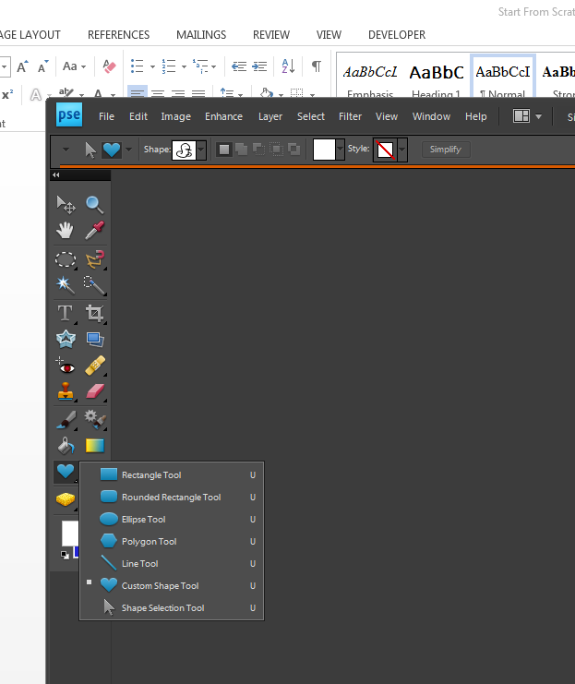
2. Use the shape tool (whichever shapes you need) to create your background. I used the rectangle tool 2x to divide my canvas into a grass and skyline, and then used the paint can to fill in the colors blue and green. (You DON’T have to do this, but its an option. As long as you find and use “SHAPES”, you are ok.) In this version of PE, the HEART shape will take you to all the others. Don’t make the mistake of using the “COOKIE CUTTER”. I just cuts things out.

3. Next, use the brush and shape tools with the color palette to make the rest of your cartoon.. Use the custom shape tool for triangles, or stars or other odd shapes. Use the paint can to fill in the colors from the palette that you want. (Don’t laugh…but here’s my example)

4. You can also use the brushes tools to add things like grass or stars, using the paint brush tool. Just play around with all the brushes and the shapes until you get what you want.



