Making A new Music CD cover
1. Go to Google.com, and find an Album cover you would like to use as the basis of your CD artwork. I am choosing a Pink Floyd one. You can use it to determine what you draw.
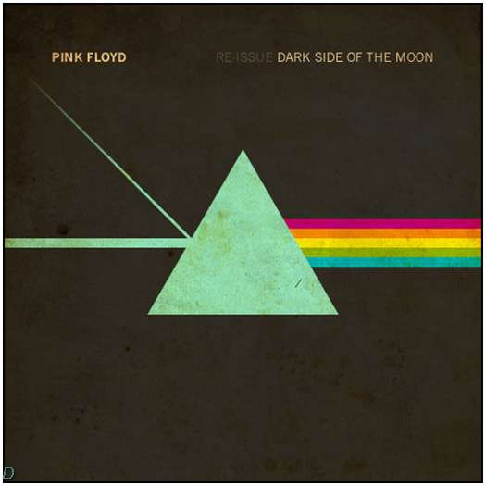
2. Open Photoshop Elements, and Go to file|New. Choose a blank option. Fill in the dialog box that comes up with a 1000X1000 pixel square in whatever color you want the background. Mine will be black. Name your file, and make sure RBG color is chosen, then click OK.
3. Use shapes to draw the triangle (in this case) or whatever shapes you are putting into the album cover. Make sure to add your own touches to make it “an original”. I used the “custom shape tool” and also “brushes” to add the streaming stars. Here’s mine:
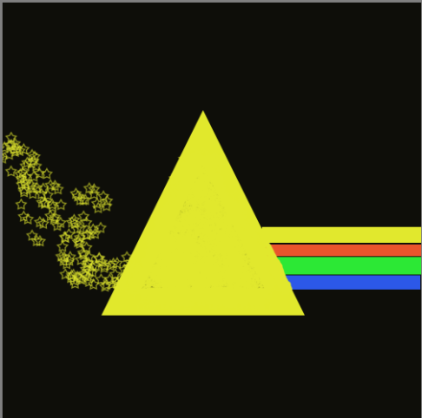
4. To make the rainbow, I used the rectangle shape tool, and used the Fill can to change the colors and fill. Then, I repainted the yellow with a brush on the triangle, so it looked behind it. (Use the eye dropper tool to match the color).

Note: Anytime you put in a shape, to go on, you may see this notice. Just say ok.
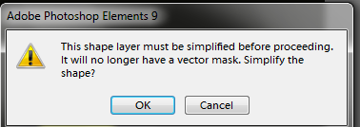
5. When you are done with all the “artwork”, but before the names….to set the picture, go to “Merge”, and choose “merge visual”. This will set your picture, and it won’t move around when you add text. Just make sure its where you want it.
5. Then, use the text tool, to write your band name. Click the text tool. Notice your tools that appear at the top. You can choose the type of font, size, and color, etc. You may need to make it larger than you think.
6. When you are finished, you can “place it” by clicking the move tool. You can also resize it that way. You can also put the Album name as well in the same way. Here is mine:

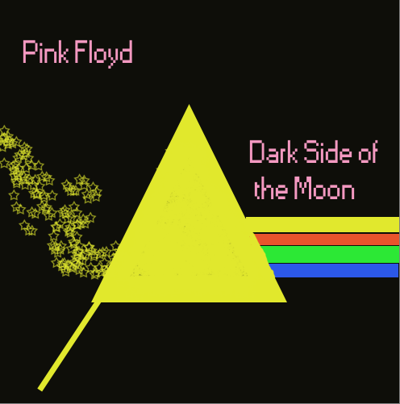
7. Save this as a gif.
8. PS. You may use ANY album cover you would like to…including pictures that you work to alter.

