This assignment is a check for understanding of the Cell Phone Etiquette readings. You should have read the information from my vestweblessons.weebly.com “Digital Citizenship page. Choose to base your cartoon on one of the articles or choose one of the 8 rules, and make a cartoon using a situation that applies to that article or rule. You can see an example using “Cyberbullying on a Phone” on the Worksheet 13: Cell Phones page.
Here are the items needed for a good grade on your cartoon:
1. Use http://www.makebeliefscomix.com/Comix/ as your cartoon editor.
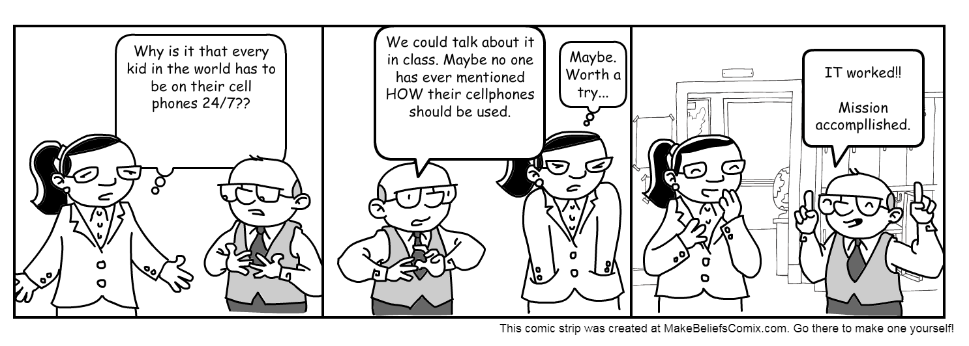
It is fairly user friendly, but here are some tips:
- Click on a panel to work on it. Use characters and backgrounds. Click them once to put them into the Selection Window. Choose the variation you want, and click again to put it in the panel.
- From there, use the left to delete, flip, overlap, and move or finally, save or print.
- Save a copy of your cartoon to your H drive.
2. It must involve one of the 8 rules or relate to one of the articles. (It might be good to use the “Panel Prompts” to show a short phrase about the rule.)
3. It must be at least 3 panels long. It must use backgrounds, characters, and talk/thought balloons.
Cell Cartoon Rubric
Evidence of understanding Rule | Super 4 points | Proficient: 3.5 | Average:3 | Needs Work:2
Graphics/cartooning | Super | Proficient | Average | Needs Work
Creativity | Super | Proficient | Average | Needs Work
Spelling, Grammar, neatness | Super | Proficient | Average | Needs Work

Total: ___________/16

