Plotting directions to class in a Flow Chart
- Plot your way from the door of my class (room 2405) to your next class.
2405 door
  - So, your START point is my doorway
  - Your END point is the doorway of your next class.
- Some things to know:
  - YOU are the moving OBJECT….keep in mind that the object COULD just as well be a person sized robot or other object. It might even be a wheelchair that a person is in.
  - Use these programming commands or OPERATIONS to do tasks needed to get to your next class doorway.
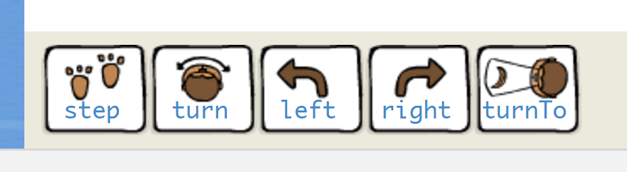
Stair Step
Up
Stair Step
Down
  - While here in class, visualize which ways you will turn, and where you will step. Leave the amounts that you will step BLANK. I will send out a few at a time to fill in the number of steps for each step command.
  - Use the back of the sheet to write down your Flow Chart.
Ovals
Rectangles
  - Use for your START and END , and

for each command or STATEMENT. Make sure to leave a blank _____ after each “step” operation, so that you can add the number of steps needed.
*Use a directional arrow between each part, so we know the order the rectangles are in.
*Keep in mind that a Flow Chart is sometimes called a “sequence” chart because it is composed of a sequence or order of events. It’s your outline for an algorithm. It must be neat and legible.

Do your flow chart on the back of this sheet or on Word. You may use a Flow chart software (in Google Drive) if you want.
Challenge: Try to make a *FUNCTION called “Stairs” which includes the steps of the landing, each step of a stair section, the turns to the next sections, the steps of the next stair section, and the steps to the doorway of the stairs.
Challenge: Make a VARIABLE. (EX: Turn right, if busy, turn left and continue to class. If not busy, continue right.)
*FUNCTION : a section of a program that has several steps, but is used fairly commonly in your program, and you don’t want to write out each statement each time…So you combine the statements to complete the whole task, and give that task a name.

