Making a GIF animation in PE
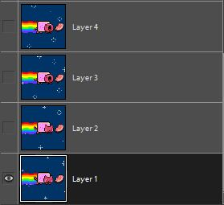
First, make the picture you want. Use something off the Internet or make the picture out of shapes and paints from Photoshop. You need to at least 2 or more different layers. If you don’t you can duplicate the first layer and then change it however you want.

Then go to File and click, Save as. Make sure you save it as a compuserve GIF
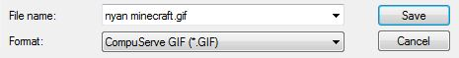
A box will appear. You will need to go to Format and select, CompuServe GIF (*.GIF)
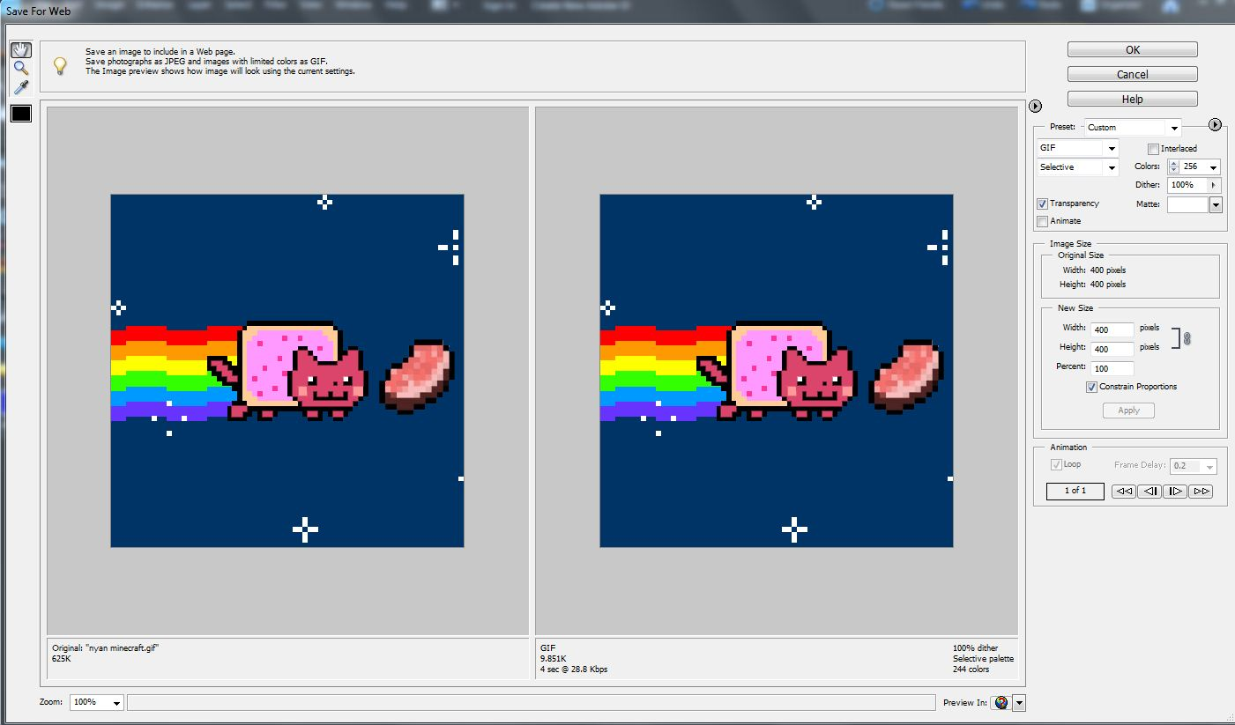
Then click, Save.

Once you click save, the box above will appear. Then find the Preset box.
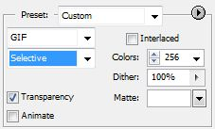

You will need to uncheck the Transparency box and check the Animate box. So it looks like this.
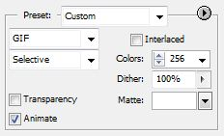
You can also change the delay of the picture that will change.
Just change the Frame Delay.
Once you are done click, OK.
Then another save box will appear, just save it to your file directory. Now, it should move as an animation when opened.

