“Impressions Poster” Desktop Publishing in Word

Required items in your poster:
_____: 5+ graphics from file related to you
_____: A picture or more that you brought from home, or took on a camera and got onto your computer.
_____: Answer 6 questions about you from the “Impressions” list, and include
_____: Insert a cooltext title from www.cooltext.com
I am also looking for:
_____: Use of shapes  _____: Use of text boxes  _____: Use of borders  _____: Use of effects, like shadow | _____: Use of line and fill colors in text boxes, graphics, and shapes  _____: ability to change and manipulate fonts to fit one whole page only  _____: Fills one whole page/no more no less.

Things you may need help with:

Inserting images from the Internet
1. Locate the image online that you want to place on your poster. Make sure it is NOT the thumbnail version.
2. Right Click on that image and choose “save image as” from the drop down menu.
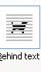
3. Rename and save the image in a folder on your computer.
4. Insert the picture from that folder into Word.
5. Select the image by clicking on it. Then click on the Text Wrapping tool in the Format Tab>Arrange ribbon. Select Behind Text. This will allow you to move the image anywhere on the page by its 4 sided arrow.
6. You can resize the image by dragging from any corner toward or away from the center of the image. Be sure to not change the size so much that it ruins the picture.

Making Borders around your Image
Select the image to put a border around it.
2. Click on the FORMAT tab at the top.
3. Choose your color, weight, and dashes(pattern)
Ah, so many choices!

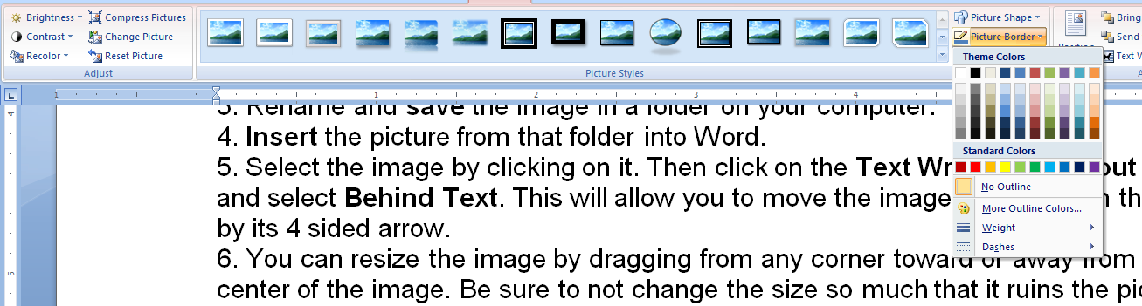
Inserting a table if applicable
1. Go up to Insert in the menu tab bar.
2. Choose Table|Insert table..(or use the boxes, just make sure you have your cursor where you want the table to be).
3. Choose the number of columns and rows you would like, and click OK.
4
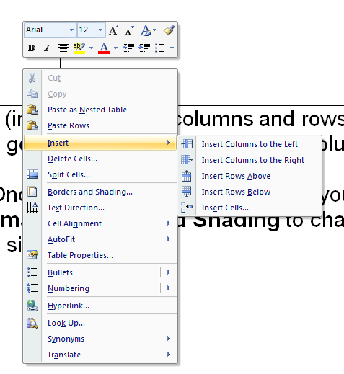
Note that you can add (insert) or delete columns and rows by clicking right inside your table, and going to insert rows…or insert columns….you can also delete using delete cells

5. Once you have created the table, you can also click right, and go up to Format | Borders and Shading to change borders and fill colors and sizes.

Inserting Text Boxes
1. To insert text in textboxes, click on the insert | textbox dropdown. I wouldn’t use the preloaded ones…I would click the “draw text box”, and click where you want the textbox to be…all the while, keeping items from moving around. This is one of the job skills to learn with doing a poster like this)
2. To place it, Click on the screen (A + will show, and you can drag your box to insert your text. Move it with the 4 sided arrows in left corner to the location you want.
3. Type inside the box.
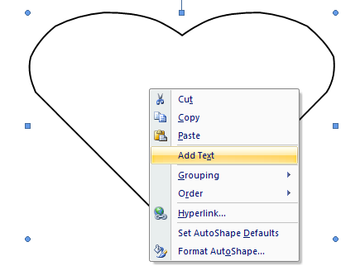
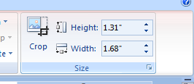
4. Change the font style, size, and color by selecting the text and changing your options using the formatting toolbar.
Last note: to get to most drawing tools, you must highlight your image, and then click the “Format” tab.
“Fill” refers to colors, pictures, etc. inside the box…”Text” refers to fonts…”Outlines” refer to borders. Be sure to check out the 3-D and shadow effects.
If you need to crop a picture, look in the “Format” tab once you’ve highlighted a picture, and there is a crop button in the top right corner. Use it like a key, and put the key in each of the sides where a black line is to move/crop it out.
SEE?????
Here’s what a textbox looks like, *You can also put text in autoshapes, by right clicking on it, and choosing “add text”.

Impressions List:
In a nutshell, this is a “getting to know you poster. Choose at least 4 of these questions to answer in textboxes or shapes within your poster. Have fun with it. (They may be put up in the class or hall…just letting you know)

- My most important character traits are ______________
- My friends will tell you that I am __________
- One thing most people don’t know about me is ________________
- A famous person I admire is __________________because_________________
- One question I have about life is ______________________
- I am proud of my __________________
- My pet peeve is __________________________
- The thing that stresses me out most is _________________
- If I had a hundred dollars, I would __________________
- It was so easy to learn _________________
- It was so difficult for me to learn____________________________
- My favorite song is _______________ because ___________
- One dish I can cook really well is ____________________
- The bravest thing I ever did was ____________________
- I am an expert on _______________________
- My teachers last year will tell you that ______________________.
- In my spare time, my favorite hobby is _____________________.
- I am obsessed with _____________________.

