My Academic Portfolio
When my daughter went away to college, in her very first class, she was asked to put all of her assignments in a web portfolio. Although the professor assumed that she was proficient at this (being a digital native and all), she had never made a web portfolio in high school, and had very little idea of how one was put together. For a freshman, the combination of college level material AND showing technical proficiency in highlighting her assignments presented some difficulty.
These 9 weeks, you will have the opportunity to create a live website portfolio detailing your educational endeavors this year. We’ll work on this periodically to showcase your work in your four core subjects, and in your ASCTI class.
Your objective is to gain experience in using digital communications. You will develop knowledge by using various programs to produce materials, research information, and refine your writing skills. Along the way, you will practice good digital ethics. I hope that you will use your website portfolio to profile samples of your best work, and develop goals and aspirations that you can communicate to prospective colleges, and careers you wish to pursue.
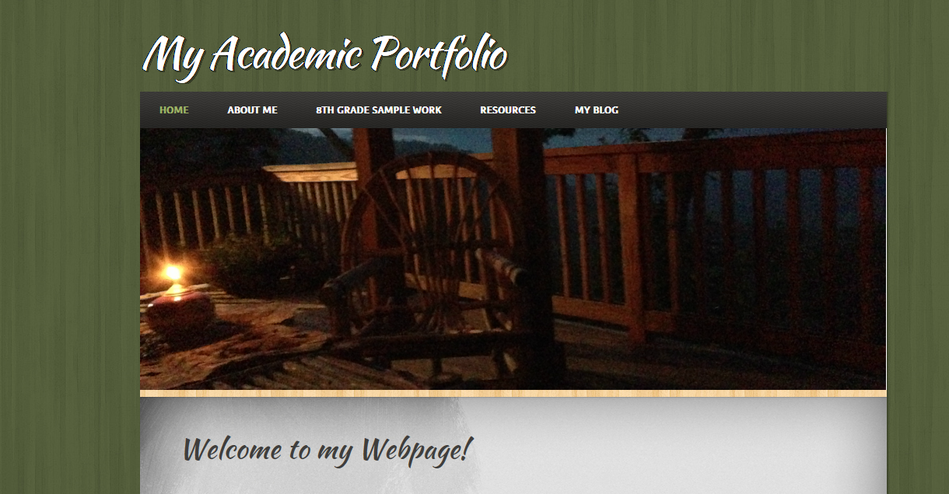
Who might see an online portfolio??
Professional!
When to use?
You will be using Weebly.com to create your website portfolio. It will include a Welcome page, an “About Me” page, an “8th Grade Classes” page with sub-pages, a resources links page, and a blog (where you will have Digital Issue” questions to expound upon.
To begin, go to www.weebly.com and register for your two free websites. (Use your lunchpin@gws.gaggle.net email as your registering email. Your first considerations are finding a design you like, organizing your first 3 pages, and finding banners and images that are appropriate for you. Remember to include citations for anything you use that doesn’t belong to you.
Main Business Technology Standards addressed:
MLB--‐2.1 Use hardware devices and software applications to enhance learning
MLB--‐3.6 Integrate data between word processing, spreadsheet, presentation, and internet applications
Domain–Digital Citizenship Core Standard 5 Students integrate technology in a social, legal, ethical, and safe manner to Be lifelong digital citizens.
MLB--‐6.1Identify personal and family morals, values, and ethics
MLB--‐6.2Explore and describe personal aptitudes, interests, and skills through the use of personal assessments
MLB--‐6.3 Explore personal priorities and goals for life and career
MLB--‐16.1 Identify and Create personal and business correspondence which displays: clarity, professionalism, relevancy, and confidentiality
MLB--‐16.6 Create format, edit, store, and distribute academic, professional, and personal documents for the appropriate audience, purpose, and situation

About Me Pages: http://www.thesitsgirls.com/blogging/10-ways-how-to-write-about-me-page/
http://www.smashingmagazine.com/2009/07/01/best-practices-for-effective-design-of-about-us-pages/
http://www.onextrapixel.com/2010/09/06/how-to-write-an-effective-about-me-page/
http://www.studentguidewebdesign.com/portfolio-basics-for-web-design-students-about-me-pages/

Content Hierarchy
All the information on your about page doesn’t have to be about your academics or a career. You want to be able to structure your content so that your target audience gets the information they need to make a decision as soon as they land on your page, but if they want to learn more about you as an individual, they can find it lower down. Make sure you always start with real-world experiences and relevant personality traits first. From there, you can mention more personal information such as location, personal interests, formal education, etc. If you were to make an ordered list of what should appear first on your about page, it should look something like this:
  - 1. Name and your school and areas of specialty, clubs, sports, music?
  - 2. Experiences
  - 3. Education
  - 4. Recognition (Have you won any awards at school? How is your academics? Have you won any awards outside of school)
  - 5. Personal interests, hobbies
  - 6. Other…Aspirations for the future, goals, etc.
We live in a generation that appreciates transparency and honesty. Lying about yourself won’t get yourself very far. Be honest – if you’re a student and just starting out, be proud of that (you’re so excited about your future and career). Everyone needs to start out somewhere, so use it your advantage. Describe what you’re passionate about and what you’re currently learning to stay up-to-date for future endeavors. Highlight your potential, and if your personality can shine through on your “about page” you’ll be all set.

