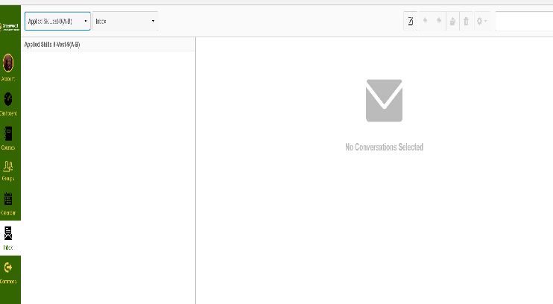
Email: Using “Canvas” to communicate:
People use email in today’s world to communicate in many ways. Although, Canvas is not an “email” in the true sense, it does have an INBOX that we can use to communicate within Applied Skills class. Take writing conventions into consideration when you are writing an email. Is the email to a FRIEND or a TEACHER? Is it a memo to a friend or a business communication? We will explore the features of this INBOX, and compose a “casual” email to a friend AND a “formal” email to a teacher.

First, some “how to” information: When you click “Compose New Message”, this dialog box will come up:
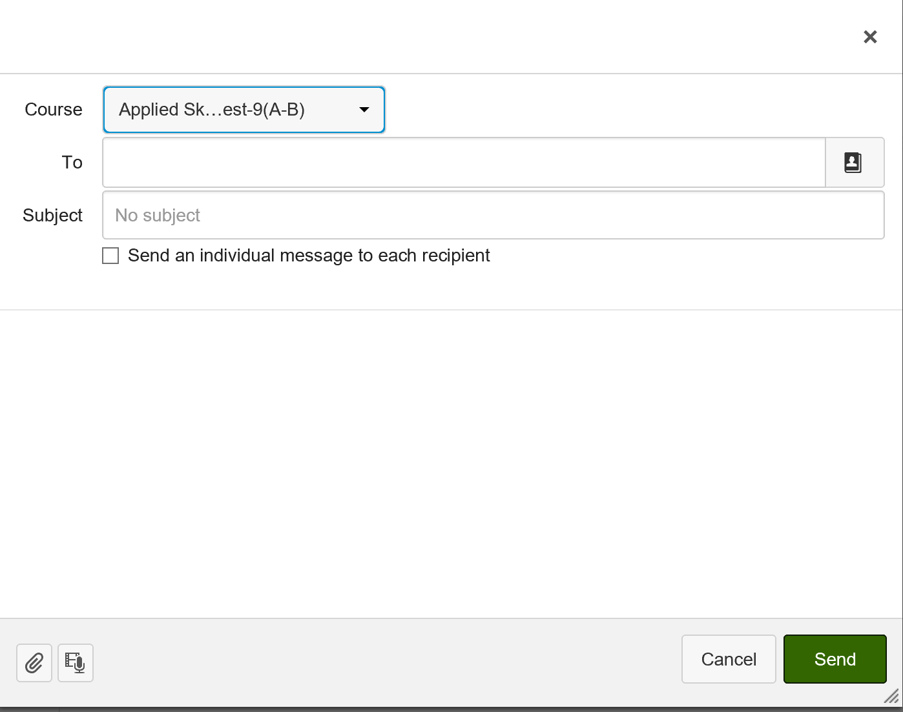
Course: Choose the Applied Skills class
To: Start to write the name of the student you wish to email OR Tami Vest for the teacher. Click the person icon to search for someone.
Subject: Write a short and informative heading
Write the body of your letter. Usually that includes:
Greeting/Salutation,
Body (Your letter: short, but great grammar and punctuation)
Closing/Sincerely,
Your name
(Signature information if applicable)
The arrow is pointing to the paper clip (which lets you attach
Pictures or other files for the recipient (the person who gets the
Email). Next to it, is the MEDIA button. You can record a voice message
Or send a video message using this button.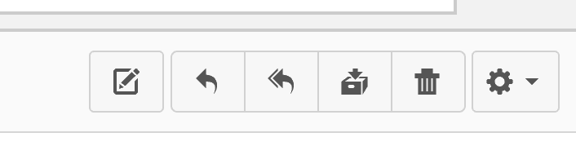
Archive
Reply to all
Reply
Compose new message
delete
These navigation buttons are present in Canvas.
*CC (Carbon copy) and bCC (hidden CC) are not part of Canvas, but are important in emails.
Write two emails according to “Writing Convention” rules.

- Friend email: (very informal)
  - Find any student that is listed in this class (any period will do) Address it to that student.
  - Subject: Did you hear what’s happening after school?
  - Body of email includes:
    - Greeting/Salutation (Hi _________,)
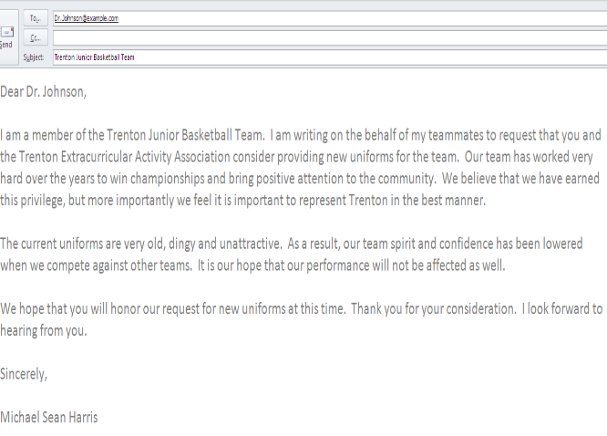
    - Body
    - Closing,
    - Your name
  - Click “Send” to send this informal email.

- Email to teacher: (formal)
  - To: tami vest (tvest@gws.k12.in.us is my real email)
  - Subject line: Please excuse my late assignment
  - Body of email includes:
    - Greeting/Salutation (Dear Mrs. Vest, )
    - Body (explanation of why your assignment will be late)
    - Closing/Sincerely,
    - Your name
    - (Signature information (initial of typist if different than addressee)
10 points

Remember these tips for formal emails:
1. Use a neutral email address (tvest@email.com sounds better than sillysoftballkitten@email.com )
2. Use a short and accurate informational subject header in the subject line
3. Use a formal salutation (Dear Mr. or Dear Mrs.)
4. Introduce yourself in the first paragraph if necessary. (My name is ________. I am contacting you concerning _____)
5. Write your actual message. Keep it short. Emails should be no more than 5 paragraphs (each with no more than 5 sentences) long. Space between each paragraph.
6. Use the correct closing. (Yours sincerely, Sincerely, Respectfully, Your student are all fine)
7. Sign your full name…and if you have a job title, include that in the line under your name
8. Proofread your email for content. Make sure you haven’t left anything important out…or that you haven’t repeated yourself. (Peer editing is great…)
9. Proofread your email for spelling and grammar. (If there is no spell check, copy your email into Word to check it)

