Pay Attention

|  |
| --- |
| http://www.salisbury.edu/careerservices/students/images/Email/email3.gifLeast formal Most Formal |

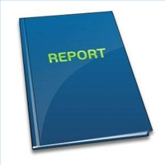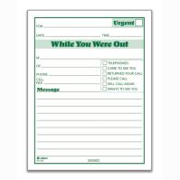

**Phone message to a family member**

**Major School Assignment**

**Typical school assignment**

**Email to a friend**

**Sticky note to self**

|  |  |  |  |  |  |  |  |  |  |
| --- | --- | --- | --- | --- | --- | --- | --- | --- | --- |
| 1 | 2 | 3 | 4 | 5 | 6 | 7 | 8 | 9 | 10 |

**Business email  
Job App Scholarship essay  
ISTEP writing**

**Class notes for personal study use**

**School Writing prompts**

**Thank you note to a relative**

**Texting a friend**

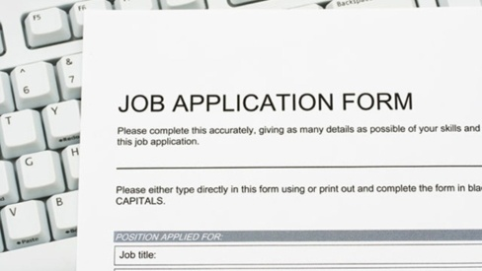





To writing Convention!